Comparing Sparse, Dense, and Hybrid Retrieval for Grounded RAG Systems

Abstract
This project explores how different retrieval methods impact grounding and reliability in Retrieval Augmented Generation (RAG) systems. The system uses a corpus of academic papers related to RAG and hallucination detection, where each paper is split into its abstract and conclusion for retrieval. Although the main focus is retrieval, a simple training pipeline is included to ensure the system is complete & reproducible.
I evaluate the retrieval methods using a set of held out queries and standard metrics like Recall@k, Hit@k, and Mean Reciprocal Rank (MRR). The results show that sparse retrieval performs best at ranking the correct documents first, while dense retrieval does not significantly improve recall at higher k values and struggles with ranking. Hybrid retrieval combines both approaches and improves over dense retrieval in some cases, but does not outperform sparse overall.
These results suggest that for smaller, domain specific datasets, simple keyword based retrieval can be very effective, while dense and hybrid methods require better ranking strategies to perform consistently.

Problem Statement
Large language models (LLMs) are very powerful, but they often generate incorrect info, which is commonly referred to as hallucination. This is a big issue because it reduces trust in the system, especially in domains like research, medicine, or education where accuracy is important. One way to reduce hallucinations is to use retrieval based methods that bring in real, external information to support model outputs.RAG systems are designed to address this problem by retrieving relevant documents and using them to ground responses. Because of this, the quality of the retrieval step is very important. If the system retrieves the wrong documents or ranks them poorly, the final output can still be unreliable.

Task Definition
The goal of this project is to evaluate different retrieval strategies for grounding research papers in a RAG system. The system retrieves relevant documents from a corpus of academic papers based on a given query. Each paper is represented using its abstract and conclusion, which are treated as individual retrieval chunks.

Why it matters
This task is important because retrieval directly affects how trustworthy and reliable a RAG system is. If the system retrieves the correct documents and ranks them highly, it improves grounding and reduces hallucination. Better retrieval leads to better factual accuracy and more trustworthy outputs.

Summary of Approach
In this project, three different retrieval approaches are implemented & compared
- Sparse retrieval uses TF-IDF to match keywords between the query and documents.
- Dense retrieval uses sentence embeddings to capture semantic similarity.
- Hybrid retrieval combines both methods using a ranking fusion approach.
These methods are evaluated on a held out set of queries using metrics such as Recall@k, Hit@k, and Mean Reciprocal Rank (MRR). All methods are evaluated using the same dataset, queries, and metrics to ensure a fair comparison.

Summary of Findings
Sparse retrieval performs the best at ranking the correct documents at the top, getting a MRR of 1.0 at k=3, meaning it consistently places the correct result first.
Dense retrieval does not significantly improve as k increases, getting Recall@5 ≈ 0.86, but performs worse at ranking (MRR@3 ≈ 0.88).
Hybrid retrieval combines both approaches and matches sparse retrieval in recall and hit rate at k=3 in some cases, but does not outperform sparse overall and still shows slightly lower ranking performance (MRR@3 ≈ 0.92).
The results show that sparse retrieval works very well for this type of domain specific dataset, while dense and hybrid methods can improve coverage but still struggle with ranking quality.

2. Related Work / Background
RAG is widely used to improve large language models by grounding their outputs in external knowledge. Instead of relying only on internal model knowledge, RAG systems retrieve relevant documents to support responses, which helps improve accuracy and transparency. Survey papers in this area show that RAG can reduce outdated information and increase trust in model outputs.
A primary motivation for RAG is the hallucination problem in LLMs, where models generate incorrect or unsupported information. Prior work has explored different ways to detect, evaluate, and mitigate hallucinations, including specialized datasets and evaluation frameworks. These studies highlight that hallucination remains a major challenge, especially in open-ended generation tasks.
Retrieval methods play a central role in RAG systems. Sparse retrieval uses keyword matching and often performs well when there is strong overlap between query and document text. Dense retrieval uses embeddings to capture semantic similarity, but can struggle with precise matching. Hybrid retrieval methods combine both approaches to improve performance, though their effectiveness depends on how results are ranked.
Another important area is attribution and evaluation. Several works focus on verifying whether generated outputs are supported by retrieved sources. These include approaches for citation attribution, source grounding, and evaluation metrics for factuality. Together, this literature emphasizes that both retrieval quality and evaluation methods are critical for building reliable and trustworthy RAG systems.
This project builds on these ideas by comparing sparse, dense, and hybrid retrieval methods on a research paper corpus, focusing on how retrieval choice impacts grounding performance. I have provided some of the papers I found the most useful in understanding the topics discussed
For RAG systems / surveys
- paper_008 — Retrieval-Augmented Generation for Large Language Models: A Survey
- paper_021 — Evaluation of Retrieval-Augmented Generation: A Survey
- paper_023 — Retrieval Augmented Generation Evaluation in the Era of Large Language Models: A Comprehensive Survey
For hallucination / factuality
- paper_003 — WACK / hallucination interventions
- paper_013 — RAGTruth
- paper_018 — hallucination mitigation survey
- paper_019 — factuality survey
- paper_025 — factuality survey
- paper_032 — DiaHalu
For retrieval methods
- paper_007 — Sparse, Dense, and Attentional Representations for Text Retrieval
- paper_004 and paper_028 — chunking / retrieval quality in RAG
For attribution / evaluation
- paper_002 — VISA
- paper_010 — CiteME
- paper_012 — Source Attribution in RAG
- paper_029 — Automatic Evaluation of Attribution
- paper_031 — attribution survey
- paper_026 — critical evaluation of factuality metrics

3. Data / Dataset / Corpus
The dataset used in this project consists of a custom JSONL corpus of academic research papers related to RAG, hallucination detection, and evaluation methods. Each paper is represented using two sections; its abstract and conclusion, which are treated as separate retrieval chunks. This structure allows the system to capture key high-level insights from each paper while keeping the dataset manageable.
During preprocessing, all entries are converted into a unified format with a single "text" field, and stored in JSONL format for easy loading and processing. Each abstract and conclusion shares the same doc_id, which allows them to be grouped as part of the same paper during evaluation.
The final dataset contains 64 papers, resulting in 128 total text chunks (one abstract and one conclusion per paper), as shown in the output of the data loading step in cell 3.For evaluation, a set of 12 queries where each is paired with one or more correct document IDs (gold_doc_ids). This evaluation set is stored separately and loaded during the retrieval evaluation phase in Cells 50–52.

Structure
Each line in the JSONL corpus represents a single text chunk (either an abstract or a conclusion) from a research paper. Each entry contains the following fields:
- doc_id – unique identifier for the paper (shared across its abstract and conclusion)
- title – full title of the paper
- authors – list of authors
- year – publication year
- source – venue or source (e.g., arXiv, ACL)
- section – indicates whether the text is an "abstract" or "conclusion"
- text – the actual content used for retrieval
Each paper appears twice in the dataset: once for the abstract and once for the conclusion, both linked by the same doc_id.

Preprocessing
- The raw paper data is cleaned and standardized to ensure consistency across all entries before being used in the retrieval pipeline.
- All content (both abstracts & conclusions) is stored under a single "text" field to simplify loading and retrieval.
- The dataset is stored in JSONL format, where each line is a separate JSON object, making it easy to read and process.
- Each paper has a unique doc_id, and both its abstract and conclusion share this ID so they can be grouped during evaluation.

Dataset Size
- The dataset contains 64 unique research papers.
- Each paper is split into two sections (abstract and conclusion), resulting in 128 total retrieval chunks.

Evaluation Setup
A held out evaluation set of 12 queries is used to test retrieval performance. Each query is paired with one or more correct document IDs (gold_doc_ids), which represent the papers that should be retrieved for that query. This evaluation set is stored in a separate JSON file and loaded during the evaluation stage in cells 50 to 52. All retrieval methods are tested on the same queries to ensure a fair comparison.

Ethics / Bias
This dataset consists only of academic research papers, which has a domain bias toward NLP and RAG related topics. While this makes the evaluation more focused and consistent, it may limit how well the results generalize to other domains or real world applications.

4. Method

System Overview
The system follows a simple retrieval-based pipeline:
Query → Retrieval → Ranked Documents → Evaluation
Given a user query, the system retrieves the most relevant documents from the corpus using a selected retrieval method. These documents are then ranked based on similarity to the query. The ranked results are compared against ground-truth document IDs to evaluate performance using metrics such as Recall@k, Hit@k, and MRR.

Retrieval Methods

Sparse Retrieval
Sparse retrieval is implemented using a TF-IDF (Term Frequency Inverse Document Frequency) representation. In this both queries and documents are converted into high dimensional vectors based on word frequency. Retrieval is performed by comparing these vectors using cosine similarity.
This method relies on keyword matching, meaning it works best when there is strong overlap between the words in the query and the document text. Because of this, sparse retrieval tends to perform well on domain specific datasets where similar terminology is used consistently.
The sparse retrieval pipeline shows up in
- Cell 38 (TF-IDF vectorization)
- Cell 40 (retrieval function)

Dense Retrieval
Dense retrieval is implemented using sentence embeddings generated by a pretrained SentenceTransformer model. This means both queries and documents are encoded into dense vector representations that capture semantic meaning rather than just exact word overlap. Retrieval is performed by computing cosine similarity between the query embedding and document embeddings.
Unlike sparse retrieval, dense retrieval can match queries and documents even when they use different wording, making it more flexible for capturing semantic relationships. However, this can sometimes reduce precision, especially in technical domains where exact terminology is important.
The dense retrieval pipeline shows up in
- Cell 39 (embedding model and document encoding)
- Cell 41 (dense retrieval function)

Hybrid Retrieval
Hybrid retrieval combines both sparse and dense methods using a ranking fusion approach. In this project, Reciprocal Rank Fusion (RRF) is used to merge the results from sparse and dense retrieval into a single ranked list. Each document is assigned a score based on its rank in each method, and these scores are combined to produce a final ranking.
The goal of hybrid retrieval is to take advantage of both keyword matching from sparse retrieval and semantic similarity from dense retrieval. This allows the system to improve overall coverage and recover relevant documents that might be missed by either method alone; but the effectiveness of hybrid retrieval depends on how well the ranking signals are combined.
The hybrid retrieval pipeline shows up in
- Cell 42 (hybrid retrieval using Reciprocal Rank Fusion)

Key Design Choices
I made my design choices to keep the system simple and easy to evaluate.
- Chunking (abstract + conclusion)
Each paper is split into two chunks, its abstract and conclusion. These sections contain the most important high level information, which makes them useful for retrieval while keeping the dataset small and manageable.
- k values (k = 3 and k = 5)
Retrieval performance is evaluated at two cutoff values, k = 3 and k = 5. Using k = 3 focuses on how well the system ranks the most relevant documents at the top, while k = 5 evaluates how well the system retrieves relevant documents overall.
- Document-level evaluation
Evaluation is performed at the document level using doc_id, rather than distinguishing between abstract and conclusion. This simplifies the evaluation process and focuses on whether the system retrieves the correct paper, not depending on which section was returned.

Parameter-Efficient Fine-Tuning (LoRA)
- where LoRA is applied
  - attention layers (Wq, Wk, Wv)
- hyperparameters
  - rank = 4
  - alpha = 1.0
- training setup
  - same dataset
  - 30 steps
  - AdamW optimizer
To evaluate parameter efficient adaptation, I applied Low-Rank Adaptation (LoRA) to the GPT model used in the pipeline. LoRA is applied to the query, key, and value projection matrices in each attention layer. The original model weights are frozen, and only the low rank matrices are trained. Training is performed for 30 steps using the same dataset and optimizer settings as the base model.

5. Experimental Setup

Base vs Adapted System
- Base system: GPT model without adaptation
- Adapted system: GPT model with LoRA applied
In this project, the base and adapted systems are defined in terms of model adaptation rather than retrieval strategy. The base system refers to the original GPT style model without any parameter efficient fine tuning, and the adapted system refers to the same model with LoRA applied to its attention layers. This allows for direct comparison between standard training and parameter efficient adaptation under the same conditions.
The retrieval methods (sparse, dense, and hybrid) are evaluated separately as part of the system design. Each retrieval approach uses the same dataset, queries, and evaluation procedure, for a fair comparison of retrieval performance independent of model adaptation.

Metrics
To evaluate retrieval performance, three standard metrics are used
- Recall@k measures how many of the correct documents (gold_doc_ids) are retrieved within the top k results. This shows how well the system covers relevant documents.
- Hit@k Checks whether at least one correct document appears in the top k results. This is a simple measure of whether the system retrieves anything relevant.
- Mean Reciprocal Rank (MRR) measures how early the first correct document appears in the ranked list. A higher MRR means the system is better at placing correct results near the top.
All metrics are computed using the same evaluation functions in Cell 53–55

Evaluation Procedure
All retrieval methods are evaluated under the same conditions to ensure a fair comparison
- Same queries - Each method is tested on the same set of 12 held-out evaluation queries.
- Same corpus - All methods retrieve documents from the same fixed dataset of research paper abstracts and conclusions.
- Same metrics - Performance is measured using the same evaluation metrics, Recall@k, Hit@k, and MRR.
By keeping the queries, dataset, and evaluation metrics the same across all methods, the comparison directly reflects differences in retrieval strategy rather than differences in experimental setup. This follows the requirement that both base and adapted systems must be evaluated using the same task, data, and evaluation procedure.

6. Results

Method | Recall@3 | Hit@3 | MRR@3 | Recall@5 | Hit@5 | MRR@5
Sparse | 0.9028 | 1.0 | 1.0 | 0.9444 | 1.0 | 1.0
Dense | 0.8611 | 0.9167 | 0.875 | 0.8611 | 0.9167 | 0.875
Hybrid | 0.8611 | 0.9167 | 0.9167 | 0.9444 | 1.0 | 0.9375

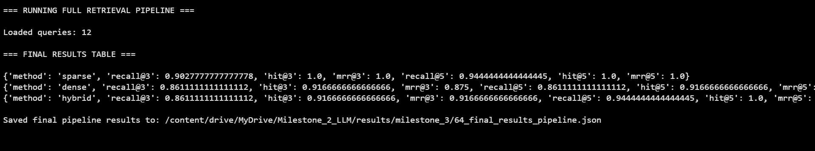

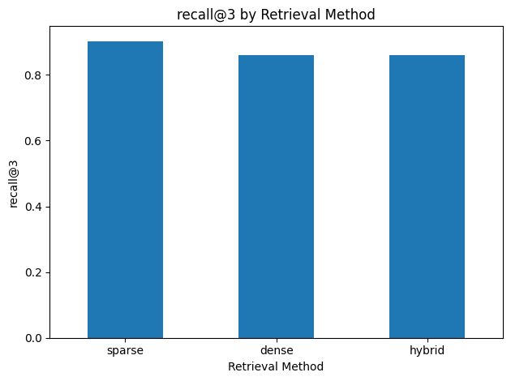
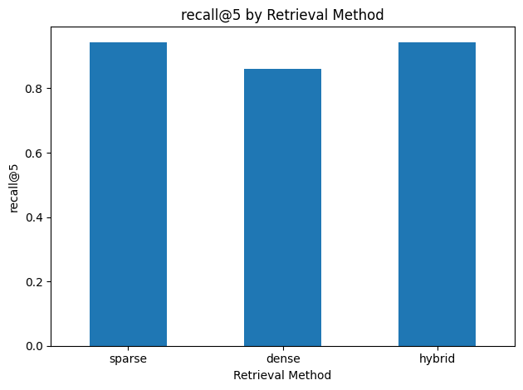
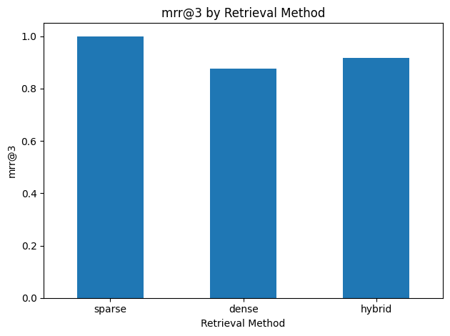
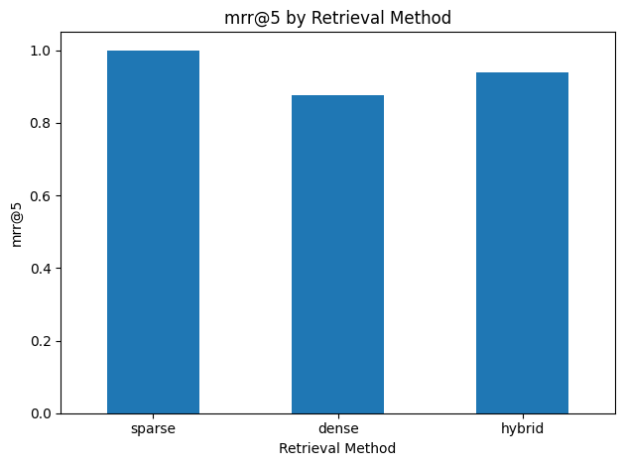

These graphs show the performance of sparse, dense, and hybrid retrieval methods across Recall@3, Recall@5, MRR@3, and MRR@5. Sparse retrieval performs the best, especially in terms of ranking, achieving perfect MRR scores, which means it consistently places the correct document first. Hybrid retrieval performs slightly better than dense retrieval, especially at higher k values, where it matches sparse retrieval in Recall@5 and Hit@5, showing that it can improve coverage by combining both methods. Hybrid still falls short of sparse retrieval in ranking performance. Dense retrieval has the lowest performance overall, especially in MRR, so even though it can retrieve relevant documents, it often ranks them lower. These results suggest that for this dataset, which is more domain specific, keyword based sparse retrieval is better while dense and hybrid methods help with recall but struggle with ranking quality.

- Sparse retrieval has the best ranking performance, with a perfect MRR of 1.0 at both k = 3 and k = 5, meaning it places the correct document at rank 1.
- Dense retrieval does not significantly improve at higher k values, and still struggles to rank the correct documents at the top compared to sparse retrieval.
- Hybrid retrieval provides a balance between the two approaches, matching sparse retrieval in Recall@3 and Hit@3 in some cases, and improving over dense retrieval in some scenarios. However, it does not outperform sparse retrieval overall and still shows slightly lower ranking performance.

Sparse retrieval got the highest performance across all metrics, so it seems that lexical matching is highly effective for this domain. This is likely due to the technical nature of the corpus, where queries often contain specific terminology that directly matches document text.
Dense retrieval performs worse across all metrics, suggesting that semantic embeddings may struggle to capture fine-grained distinctions in small, technical datasets.
Hybrid retrieval improves recall at k=5 to match sparse retrieval, but exhibits lower MRR, indicating that while it retrieves relevant documents, they are often ranked lower than in sparse retrieval.

LoRA Results
- Base model trainable parameters: 6,534,656
- LoRA model trainable parameters: 6,513,152
The LoRA adapted model slightly reduces the number of trainable parameters compared to the base model, since only the low rank matrices are updated while the original weights are frozen.
- Base loss: 9.56
- LoRA loss: 9.71
The base model has a final training loss of 9.56, while the LoRA-adapted model reaches a slightly higher loss of 9.71 after the same number of training steps

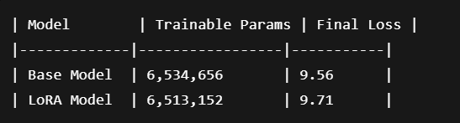
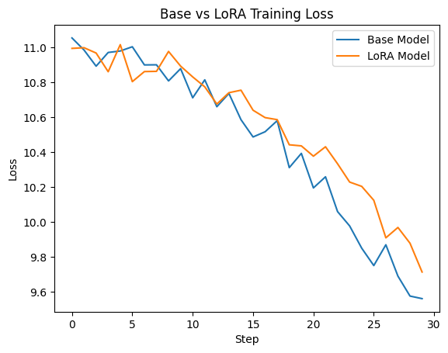
The LoRA adapted model has similar training behavior to the base model but doesn’t outperform it in terms of final loss. This is expected due to the small dataset size and limited number of training steps. Despite not improving performance, LoRA provides a more parameter efficient training approach by updating only a subset of the model parameters. This may mean that LoRA can approximate full model training behavior while reducing the need for large scale parameter updates.Here, the retrieval component has a larger impact on overall system performance than model fine tuning, possibly explaining the limited gains from LoRA adaptation.

7. Analysis

(Sort of?) Failure Case
No queries resulted in complete retrieval failure across all methods, BUT several cases highlighted important differences in ranking quality & retrieval behavior.
Query: Which paper proposes a benchmark using factual and non-factual statements to evaluate models?
Gold Document:
paper_009
Retrieved Results
- Sparse: ['paper_009', 'paper_054', 'paper_044']
- Dense: ['paper_044', 'paper_025', 'paper_026']
- Hybrid: ['paper_044', 'paper_025']
Performance
- Sparse Recall@3: 1.0
- Dense Recall@3: 0.0
- Hybrid Recall@3: 0.0

sparse retrieval successfully retrieves the correct document due to direct keyword overlap between the query and the document text. The query contains specific terms like “benchmark” and “factual and non-factual statements”, which are likely present in the relevant document.
Dense retrieval doesn’t retrieve the correct document, instead returning semantically related but incorrect papers. This could mean that the embedding model captures general topic similarity but lacks precision for distinguishing specific benchmark-related concepts.
Hybrid retrieval also fails because it relies on combining signals from both sparse and dense methods. Since dense retrieval strongly ranks incorrect documents, the fusion process prioritizes those results, leading to incorrect top ranked outputs.

Overall
This example shows that ranking quality is more important than recall. Even though dense retrieval can find related documents, it struggles to rank them correctly. Sparse retrieval performs better in this dataset because it relies on exact keyword matching, which is effective for domain-specific datasets like academic research papers.

Analysis Cases
Query:
Which papers discuss faithfulness evaluation methods that align well with human judgment?
Relevant Documents:
paper_001, paper_006
Retrieved Results:
- Sparse: paper_006, paper_062
- Dense: paper_006, paper_001
- Hybrid: paper_006, paper_001
Performance:
- Sparse Recall@3: 0.5
- Dense Recall@3: 1.0
- Hybrid Recall@3: 1.0
all retrieval methods successfully return at least one relevant document, but there are differences in coverage. Sparse retrieval only retrieves one of the two relevant documents, resulting in lower Recall@3. This is probably due to reliance on exact keyword matching, which may miss semantically related papers that use slightly different phrasing.
Dense and hybrid retrieval both retrieve all relevant documents, getting perfect Recall@3. This means that semantic embeddings are effective at capturing relationships between similar papers, even when wording differs. However, all methods achieve the same ranking performance (MRR = 1.0),they correctly place a relevant document at the top. This case shows that dense and hybrid retrieval can improve coverage, even when ranking quality is similar across methods.
Query:
What are the limitations of dense retrieval with fixed-length representations?
Relevant Document:
paper_007
Retrieved Results:
- Sparse: paper_007, paper_004
- Dense: paper_007, paper_021
- Hybrid: paper_007, paper_004
Performance:
- Sparse Recall@3: 1.0
- Dense Recall@3: 1.0
- Hybrid Recall@3: 1.0
All retrieval methods successfully retrieve the correct document and rank it first, resulting in perfect performance across all metrics. This shows that the query closely matches the terminology used in the relevant document. The differences between methods appear in the additional retrieved documents. Sparse and hybrid retrieval return a chunking related paper (paper_004), while dense retrieval returns a survey paper (paper_021), showing that dense retrieval emphasizes broader semantic similarity. This case shows that when there is strong alignment between query wording and document text, all retrieval methods perform equally well. It also shows that differences between methods may mostly affect secondary results rather than the top ranked document.

Query:
Which work shows that hybrid retrieval improves scalability and performance?
Relevant Document:
paper_007
Retrieved Results:
- Sparse: paper_007, paper_063, paper_008
- Dense: paper_063, paper_007
- Hybrid: paper_007, paper_063, paper_008
Performance:
- Sparse Recall@3: 1.0
- Dense Recall@3: 1.0
- Hybrid Recall@3: 1.0
- Dense MRR@3: 0.5
all methods successfully retrieve the correct document, but differ in ranking quality. Sparse and hybrid retrieval both place the correct document at rank 1, but dense retrieval ranks it second, resulting in a lower MRR. Dense retrieval prioritizes paper_063, which is semantically related to retrieval evaluation, but not the most relevant document for the query. This shows that dense embeddings capture general topic similarity but struggle to prioritize the most precise match.
Hybrid retrieval corrects this issue by incorporating sparse ranking signals, allowing it to rank the correct document first. This demonstrates that hybrid methods can improve ranking quality when dense retrieval alone is insufficient.

8. Limitations and Responsible Use

Limitations
This project has several limitations. First, the dataset is small, consisting of around 64research papers, which limits the diversity of content and may affect how well the results generalize. Second, the evaluation queries are hand written, which may introduce bias and do not fully represent real user queries. Also the system is not tested on real-world inputs, so performance in practical applications may differ. Finally, the hybrid retrieval method is not fully optimized and its ranking strategy could be improved to better combine sparse and dense signals.

Risks
The dataset consists only of academic research papers, which introduces a domain bias toward NLP and RAG-related topics. This means the system may not perform well outside this domain. Another risk is that retrieval errors can lead to misleading results, especially if incorrect documents are ranked highly. Because of this, the system should not be relied on for critical applications without further validation and improvement. This is only for RAG related queries!

9. Conclusion

Main Takeaway
The results of this project show that sparse retrieval performs very well on domain specific datasets, especially when queries and documents share similar terminology. Dense retrieval is useful for improving recall at higher values of k, but it struggles to rank the most relevant documents at the top. Hybrid retrieval combines both approaches, but in this project it did not outperform sparse retrieval, mainly due to limitations in its ranking strategy.

Lessons Learned
One key takeaway from this project is that evaluation is more important than model complexity. Even simple methods like TF-IDF can perform very well when properly evaluated. Another important lesson is that retrieval performance is highly dependent on the dataset, especially in technical domains where exact terminology plays a large role.

Future Work
There are several directions for improving this system. Hybrid retrieval could be improved by using a more advanced ranking or fusion method, also expanding the dataset to include more papers would make the evaluation more robust and realistic. Finally, future work could explore section level evaluation, where abstracts and conclusions are treated separately, to better understand how different parts of documents contribute to retrieval performance.

References

Paper 001
Malin, B., Kalganova, T., & Boulgouris, N. (2025). A Review of Faithfulness Metrics for Hallucination Assessment in Large Language Models. IEEE JSTSP.

Paper 002
Ma, X., Zhuang, S., Koopman, B., Zuccon, G., Chen, W., & Lin, J. (2025). VISA: Retrieval Augmented Generation with Visual Source Attribution. ACL.

Paper 003
Simhi, A., Herzig, J., Szpektor, I., & Belinkov, Y. (2024). Constructing Benchmarks and Interventions for Combating Hallucinations in LLMs. arXiv.
Paper 004
Lu, W., Chen, K., Qiao, R., & Sun, X. (2025). HiChunk: Evaluating and Enhancing Retrieval-Augmented Generation with Hierarchical Chunking. arXiv.

Paper 005
Xu, Z., Xie, S., Lv, Q., Xiao, S., Song, L., Sui, W., & Lin, F. (2025). Diagnosing Failures in Large Language Models’ Answers: Integrating Error Attribution into Evaluation Framework. ACL Findings.
Paper 006
Malin, B., Kalganova, T., & Boulgouris, N. (2024). A review of faithfulness metrics for hallucination assessment in Large Language Models. arXiv.
Paper 007
Luan, Y., Eisenstein, J., Toutanova, K., & Collins, M. (2021). Sparse, Dense, and Attentional Representations for Text Retrieval. Transactions of the ACL.
Paper 008
Gao, Y., Xiong, Y., Gao, X., Jia, K., Pan, J., Bi, Y., Dai, Y., Sun, J., & Wang, H. (2023). Retrieval-Augmented Generation for Large Language Models: A Survey. arXiv.

Paper 009
Muhlgay, D., Ram, O., Magar, I., Levine, Y., Ratner, N., Belinkov, Y., Abend, O., Leyton-Brown, K., Shashua, A., & Shoham, Y. (2024). Generating Benchmarks for Factuality Evaluation of Language Models. ACL.
Paper 010
Press, O., Hochlehnert, A., Prabhu, A., Udandarao, V., Press, O., & Bethge, M. (2024). CiteME: Can Language Models Accurately Cite Scientific Claims?. NeurIPS.

Paper 011
Ye, Y., Simpson, E., & Santos Rodriguez, R. (2024). Using Similarity to Evaluate Factual Consistency in Summaries. arXiv.
Paper 012
Nematov, I., Kalai, T., Kuzmenko, E., Fugagnoli, G., Sacharidis, D., Hose, K., & Sagi, T. (2025). Source Attribution in Retrieval-Augmented Generation. arXiv.
Paper 013
Niu, C., Wu, Y., Zhu, J., Xu, S., Shum, K., Zhong, R., Song, J., & Zhang, T. (2024). RAGTruth: A Hallucination Corpus for Developing Trustworthy Retrieval-Augmented Language Models. ACL.
Paper 014
Mugaanyi, J., Cai, L., Cheng, S., Lu, C., & Huang, J. (2024). Evaluation of Large Language Model Performance and Reliability for Citations and References in Scholarly Writing: Cross-Disciplinary Study. J Med Internet Res.
Paper 015
Chen, L., Deng, Y., Bian, Y., Qin, Z., Wu, B., Chua, T.-S., & Wong, K.-F. (2023). Beyond Factuality: A Comprehensive Evaluation of Large Language Models as Knowledge Generators. arXiv.

Paper 015
Chen, L., Deng, Y., Bian, Y., Qin, Z., Wu, B., Chua, T.-S., & Wong, K.-F. (2023). Beyond Factuality: A Comprehensive Evaluation of Large Language Models as Knowledge Generators. arXiv.
Paper 016
Meyer, J. G., Urbanowicz, R. J., Martin, P. C. N., O’Connor, K., Li, R., Peng, P.-C., Bright, T. J., Tatonetti, N., Won, K. J., Gonzalez-Hernandez, G., & Moore, J. H. (2023). ChatGPT and large language models in academia: opportunities and challenges. BioData Mining.
Paper 017
Kim, T. E., & Diaz, F. (2025). Towards Fair RAG: On the Impact of Fair Ranking in Retrieval-Augmented Generation. ICTIR.
Paper 018
Tonmoy, S. M. T. I., Zaman, S. M. M., Jain, V., Rani, A., Rawte, V., Chadha, A., & Das, A. (2024). A Comprehensive Survey of Hallucination Mitigation Techniques in Large Language Models. arXiv.
Paper 019
Wang, C., Liu, X., Yue, Y., Guo, Q., Hu, X., Tang, X., Zhang, T., Jiayang, C., Yao, Y., Hu, X., Qi, Z., Gao, W., Wang, Y., Yang, L., Wang, J., Xie, X., Zhang, Z., & Zhang, Y. (2023). Survey on Factuality in Large Language Models: Knowledge, Retrieval and Domain-Specificity. ACM Comput. Surv.
Paper 020
Chang, Y., Wang, X., Wang, J., Wu, Y., Yang, L., Zhu, K., Chen, H., Yi, X., Wang, C., Wang, Y., Ye, W., Zhang, Y., Chang, Y., Yu, P. S., Yang, Q., & Xie, X. (2024). A Survey on Evaluation of Large Language Models. ACM Trans. Intell. Syst. Technol.

Paper 021
Yu, H., Gan, A., Zhang, K., Tong, S., Liu, Q., & Liu, Z. (2024). Evaluation of Retrieval-Augmented Generation: A Survey. arXiv.
Paper 022
Agrawal, A., Suzgun, M., Mackey, L., & Kalai, A. T. (2024). Do Language Models Know When They’re Hallucinating References?. ACL Findings.
Paper 023
Gan, A., Yu, H., Zhang, K., Liu, Q., Yan, W., Huang, Z., Tong, S., Chen, E., & Hu, G. (2025). Retrieval Augmented Generation Evaluation in the Era of Large Language Models: A Comprehensive Survey. Frontiers of Computer Science.
Paper 024
Zhang, W., & Zhang, J. (2025). Hallucination Mitigation for Retrieval-Augmented Large Language Models: A Review. Mathematics.
Paper 025
Wang, Y., Wang, M., Manzoor, M. A., Liu, F., Georgiev, G., Das, R. J., & Nakov, P. (2024). Factuality of Large Language Models: A Survey. EMNLP.

Paper 026
Ramprasad, S., & Wallace, B. C. (2025). Do Automatic Factuality Metrics Measure Factuality? A Critical Evaluation. NeurIPS.

Paper 027
Hu, M., He, B., Wang, Y., Li, L., Ma, C., & King, I. (2024). Mitigating Large Language Model Hallucination with Faithful Finetuning. arXiv.
Paper 028
Zhao, J., Ji, Z., Fan, Z., Wang, H., Niu, S., Tang, B., Xiong, F., & Li, Z. (2025). MoC: Mixtures of Text Chunking Learners for Retrieval-Augmented Generation System. arXiv.
Paper 029
Yue, X., Wang, B., Chen, Z., Zhang, K., Su, Y., & Sun, H. (2023). Automatic Evaluation of Attribution by Large Language Models. arXiv.
Paper 030
Zhou, W., Adel, H., Schuff, H., & Vu, N. T. (2024). Explaining Pre-Trained Language Models with Attribution Scores: An Analysis in Low-Resource Settings. arXiv.

Paper 031
Li, D., Sun, Z., Hu, X., Liu, Z., Chen, Z., Hu, B., Wu, A., & Zhang, M. (2023). A Survey of Large Language Models Attribution. arXiv.
Paper 032
Chen, K., Chen, Q., Zhou, J., He, Y., & He, L. (2024). DiaHalu: A Dialogue-level Hallucination Evaluation Benchmark for Large Language Models. EMNLP.
Paper 033
Abolghasemi, A., Azzopardi, L., Hashemi, S. H., de Rijke, M., & Verberne, S. (2025). Evaluation of Attribution Bias in Generator-Aware Retrieval-Augmented Large Language Models. arXiv.
Paper 034
Favero, A., Zancato, L., Trager, M., Choudhary, S., Perera, P., Achille, A., Swaminathan, A., & Soatto, S. (2024). Multi-Modal Hallucination Control by Visual Information Grounding. CVPR.
Paper 035
Hu, X., Ru, D., Qiu, L., Guo, Q., Zhang, T., Xu, Y., Luo, Y., Liu, P., Zhang, Y., & Zhang, Z. (2024). REFCHECKER: Reference-based Fine-grained Hallucination Checker and Benchmark for Large Language Models. arXiv.

Paper 036
Zhang, M., & Zhao, T. (2025). Citation Accuracy Challenges Posed by Large Language Models. JMIR Med Educ.
Paper 037
Oami, T., Okada, Y., & Nakada, T.-a. (2024). Performance of a Large Language Model in Screening Citations. JAMA Network Open.
Paper 038
Friel, R., & Sanyal, A. (2023). ChainPoll: A High Efficacy Method for LLM Hallucination Detection. arXiv.
Paper 039
Du, X., Xiao, C., & Li, Y. (2024). HaloScope: Harnessing Unlabeled LLM Generations for Hallucination Detection. NeurIPS.
Paper 040
Sriramanan, G., Bharti, S., Sadasivan, V. S., Saha, S., Kattakinda, P., & Feizi, S. (2024). LLM-Check: Investigating Detection of Hallucinations in Large Language Models. NeurIPS.

Paper 041
Yehuda, Y., Malkiel, I., Barkan, O., Weill, J., Ronen, R., & Koenigstein, N. (2024). InterrogateLLM: Zero-Resource Hallucination Detection in LLM-Generated Answers. arXiv.
Paper 042
Ledger, G., & Mancinni, R. (2024). Detecting LLM Hallucinations Using Monte Carlo Simulations on Token Probabilities. TechRxiv.
Paper 043
Scirè, A., Ghonim, K., & Navigli, R. (2024). FENICE: Factuality Evaluation of Summarization Based on Natural Language Inference and Claim Extraction. arXiv.
Paper 044
Muhlgay, D., Ram, O., Magar, I., Levine, Y., Ratner, N., Belinkov, Y., Abend, O., Leyton-Brown, K., Shashua, A., & Shoham, Y. (2024). Generating Benchmarks for Factuality Evaluation of Language Models. ACL.
Paper 045
Soleimani, A., Monz, C., & Worring, M. (2023). NonFactS: NonFactual Summary Generation for Factuality Evaluation in Document Summarization. ACL Findings.

Paper 046
Alansari, A., & Luqman, H. (2025). Large Language Models Hallucination: A Comprehensive Survey. arXiv.
Paper 047
Lyu, Q., Apidianaki, M., & Callison-Burch, C. (2024). Towards Faithful Model Explanation in NLP: A Survey. Computational Linguistics.
Paper 048
Zhang, W., Aliannejadi, M., Yuan, Y., Pei, J., Huang, J.-H., & Kanoulas, E. (2024). Towards Fine-Grained Citation Evaluation in Generated Text: A Comparative Analysis of Faithfulness Metrics. arXiv.
Paper 049
Kenthapadi, K., Sameki, M., & Taly, A. (2024). Grounding and Evaluation for Large Language Models: Practical Challenges and Lessons Learned. KDD.

Paper 050
Sankararaman, H., Yasin, M. N., Sorensen, T., Di Bari, A., & Stolcke, A. (2024). Provenance: A Light-weight Fact-checker for Retrieval Augmented LLM Generation Output. arXiv.

Paper 051
Fayyazi, R., Hoyos Trueba, S., Zuzak, M., & Yang, S. J. (2025). ProveRAG: Provenance-Driven Vulnerability Analysis With Automated Retrieval-Augmented LLMs. IEEE Access

Paper 052
Marin, J. (2025). Semantic Grounding Index: Geometric Bounds on Context Engagement in RAG Systems. arXiv.

Paper 053
Sorodoc, I.-T., Ribeiro, L. F. R., Blloshmi, R., Davis, C., & de Gispert, A. (2025). GaRAGe: A Benchmark with Grounding Annotations for RAG Evaluation. ACL Findings.

Paper 054
Gerner, A., Madvil, N., Barak, N., Zaikman, A., Liberman, J., Hamra, L., Brazilay, R., Tsadok, S., Friedman, Y., Harow, N., Bressler, N., Chorev, S., & Tannor, P. (2025). ORION Grounded in Context: Retrieval-Based Method for Hallucination Detection. arXiv.

Paper 055
Béchard, P., & Marquez Ayala, O. (2024). Reducing hallucination in structured outputs via Retrieval-Augmented Generation. NAACL.

Paper 056
Sun, Z., Zang, X., Zheng, K., Xu, J., Zhang, X., Yu, W., Song, Y., & Li, H. (2025). ReDeEP: Detecting Hallucination in Retrieval-Augmented Generation via Mechanistic Interpretability. ICLR.

Paper 057
Wu, W., Wang, H., Li, B., Huang, P., Zhao, X., & Liang, L. (2025). MultiRAG: A Knowledge-guided Framework for Mitigating Hallucination in Multi-source Retrieval Augmented Generation. arXiv.

Paper 058
Ding, H., Pang, L., Wei, Z., Shen, H., & Cheng, X. (2025). Rowen: Adaptive Retrieval-Augmented Generation for Hallucination Mitigation in LLMs. SIGIR-AP.

Paper 059
Li, J., Cheng, X., Zhao, W. X., Nie, J.-Y., & Wen, J.-R. (2023). HaluEval: A Large-Scale Hallucination Evaluation Benchmark for Large Language Models. arXiv.

Paper 060
Kamalloo, E., Dziri, N., Clarke, C. L. A., & Rafiei, D. (2023). Evaluating Open-Domain Question Answering in the Era of Large Language Models. ACL.

Paper 061
Li, R., Li, R., Wang, B., & Du, X. (2024). IQA-EVAL: Automatic Evaluation of Human-Model Interactive Question Answering. NeurIPS.

Paper 062
Wang, C., Cheng, S., Guo, Q., Yue, Y., Ding, B., Xu, Z., Wang, Y., Hu, X., Zhang, Z., & Zhang, Y. (2023). Evaluating Open-QA Evaluation. NeurIPS.

Paper 063
Salemi, A., & Zamani, H. (2024). Evaluating Retrieval Quality in Retrieval-Augmented Generation. SIGIR.

Paper 064
Zheng, S. (2024). A Systematic Evaluation on Leading Large Language Models and Their Factuality Investigation as Question Answering Systems. UIUC Thesis.

